Bishop Brady HIGH SCHOOL EMERGENCY ACTION PLAN  Updated 8/9/2023 | purpose  Emergencies are not predictable, require a rapid and controlled response with coordination of entire sports medicine team. For preparedness, Bishop Brady HS reviews, updates, and practices each venue specific Emergency Action Plans (EAPs) annually.  Annie Mattarazzo  Athletic Director  Riley Burns  Safe Sports Network Athletic Trainer

Table of Contents
Personnel Involved in Development 3
Documentation of Recent Changes 4
Introduction 5
Staff Education 9
Chain of Command 9
Emergency Telephone Numbers 10
Emergency Contact Tree 11
Emergency Equipment Locations 12
Bishop Brady HS AED Location 13
Emergency Action Procedures 14
(Venue Specific): Bishop Brady HS - Athletic Fields 15
(Venue Specific): Bishop Brady HS – Thomas Hardiman Gymnasium 16
(Venue Specific): Bishop Brady HS – Weight Room 17
(Venue Specific): Memorial Field 18
(Venue Specific): State Hospital/S. Fruit Street Fields 19
(Venue Specific): Shaker Road School – Soccer Fields 20
(Venue Specific): NHTI Soccer Fields 2 & 3 21
(Venue Specific): NHTI Little Hall Commons 22
(Venue Specific): Beaver Meadow Golf Course 23
(Venue Specific): Tri-Town Ice Arena 24
(Venue Specific): Everett Arena 25
(Venue Specific): JFK Coliseum 26
(Venue Specific): NEC Lee Clement Arena 27
(Venue Specific): Health Club of Concord 28
(Venue Specific): YMCA of Concord 29
(Venue Specific): Pats Peak Ski Area 30
(Venue Specific): Rollins Park – Softball Field 31
(Venue Specific): Rollins Park – Baseball Field 32
(Venue Specific): Merrill Park Tennis Courts 33
(Venue Specific): Merrimack Valley HS – Track Complex 34
Rehearsal Strategy 35
Documentation of Emergency Equipment Maintenance 37
WBGT GUIDELINES 38
Mental Health Emergency in Secondary School Athlete 39
Lightning Safety Policies 41
Other Severe Weather and Natural Disasters 42
Approval and Verification Page: 45
Coach Acknowledgement of Review of EAP 46

Personnel Involved in Development

The following individuals were involved with the creation of this Emergency Action Plan:
(Riley Burns - Safe Sports Network Athletic Trainer)
(Kate Metzger - Safe Sports Network- Former BBHS Athletic Trainer)
(Annie Mattarazzo - Athletic director)
(Dr. Pat Casey & Dr. Doug Moran - Safe Sports Network Supervising Physician)
(Dawn Belmore - Safe Sports Network Program Director)
(Dr. Gregory Soghikian - Safe Sports Network Medical Director)
(Dr. James Vailas - Former Safe Sports Network Medical Director)

Documentation of Recent Changes

As changes to the EAP are made, please list the change, page affected and date that the change was made.

Specific Changes Made | Page(s) Affected | Date
Document Created | All | 7/21/2023
Changed AT Contact Info | All | 8/7/2023
SSN Medical Director Update | 3 | 8/9/2023
*add rows as necessary

EMERGENCY ACTION PLAN FOR ATHLETICS OVERVIEW

Introduction
Emergency situations may arise at any time during athletic events. Expedient action must be taken in order to provide the best possible care to the student athlete. The development and implementation of an emergency action plan will help ensure that the best care will be provided.
As emergencies may occur at any time and during any activity, all school activities personnel must be prepared. Athletic organizations have a duty to develop an emergency action plan that may be implemented immediately when necessary and provide appropriate standards of emergency care to all sports participants. This preparation involves formulation of an emergency action plan, proper coverage of events, maintenance of appropriate emergency equipment and supplies, utilization of appropriate emergency medical personnel, and continuing education in the area of emergency medicine and planning. Through careful pre-participation physical screenings, adequate medical coverage, safe practice and training techniques and other safety avenues, some potential emergencies may be averted. However, accidents and injuries are inherent with sports participation, and proper preparation on the part of the sports medicine team should enable each emergency situation to be managed appropriately and efficiently.
Components of an Emergency Action Plan
- Emergency Personnel
- Emergency Communication
- Emergency Equipment
- Roles of First Responder
- Venue Directions with a Map
- Emergency Action Plan Checklist for Non-Medical Emergencies

Emergency Personnel
The first responder in an emergency situation during an athletic practice or competition is typically a member of the sports medicine staff, such as a certified athletic trainer. However, the first responder may also be a coach or another member of the school personnel.
Certification in cardiopulmonary resuscitation (CPR), first aid, automated external defibrillator (AED), emergency action plan and procedures review, and prevention of disease transmission, and emergency plan review is required for all athletics personnel associated with practices, competitions, skills instructions, and strength and conditioning [which could include the athletic director, school nurse, certified athletic trainer, all coaches, etc.]. Copies of training certificates and/or cards should be maintained with the athletic director. All coaches are required to have CPR, First Aid, AED, and concussion management training certifications.

The emergency team may consist of physicians, emergency medical technicians, certified athletic trainers, athletic training students, coaches, managers, and possibly even bystanders. Roles of these individuals will vary depending on different factors such as team size, athletic venue, personnel present, etc.
The four basic roles within the emergency team are:
- Establish scene safety and immediate care of the athlete:
  - This should be provided by the most qualified individual on the medical team (the first individual in the chain of command).
- Activation of Emergency Medical Services:
  - This may be necessary in situations where emergency transportation is not already present at the sporting event. Time is the most critical factor, and this may be done by anyone on the team.
- Equipment Retrieval:
  - May be done by anyone on the emergency team who is familiar with the types and locations of the specific equipment needed.
- Direction of EMS to the scene:
  - One of the members of the team should be in charge of meeting the emergency personnel as they arrive at the site. This person should have keys to locked gates/doors.

Activating Emergency Medical Services
Call 9-1-1
Provide information
- Name, address, telephone number of caller
- Nature of the emergency (medical or non-medical) *
- Number of athletes
- Condition of athlete(s)
- First aid treatment initiated by first responder
- Specific directions as needed to locate the emergency scene (i.e., “use the south entrance to the school off Asylum St.”)
- Other information requested by the dispatcher
- DO NOT HANG UP FIRST
*If non-medical, refer to the specified checklist of the school’s non-athletics emergency action plan

Emergency Communication
Communication is key to a quick, efficient emergency response. There is a pre-established phone tree to ensure all relevant parties are notified. Access to a working telephone line or other device, either fixed or mobile, should be assured. There should also be back-up communication in effect in case there is a failure of the primary communication. At every athletic venue, home and away, it is important to know the location of a workable telephone. Please see page 11 for emergency communication guidelines for Bishop Brady High School.
Medical Emergency Transportation
Any emergency situation where there is loss of consciousness (LOC), or impairment of airway, breathing, or circulation (ABCs) or there is a neurovascular compromise should be considered a “load and go” situation and emphasis is placed on rapid evaluation, treatment, and proper transportation. Any emergency personnel who experience doubt in their mind regarding the severity of the situation should consider a “load and go” situation and transport the individual.

Non-Medical Emergencies
For the non-medical emergencies (fire, bomb threats, violent or criminal behavior, etc.) refer to the school emergency action plan and follow instructions.
Post EAP Activation Procedures:
Documentation
Documentation must be done by AT (or other provider) and/or coach immediately following activation of the EAP. Both an injury report and accident report form should be filled out.

Debriefing
A team comprising of the AT, AD, coaches, and if available, school nurse and one or two other school district employees not involved with the situation should discuss the event within two days. This team should evaluate the effectiveness of the EAP and conduct a staff debriefing. A specific timeline and action items for changes to EAP should be made for promptness.

Conclusion
The importance of being properly prepared when athletic emergencies arise is paramount. An athlete’s survival may hinge on the training and preparation of healthcare providers. It is prudent to invest athletic department “ownership” in the emergency action plan by involving the athletic administration and sport coaches as well as sports medicine personnel. The emergency action plan should be reviewed at least once a year with all athletic personnel and local emergency response teams (i.e., fire, police, EMTs, paramedics). Through development and implementation of the emergency plan, Bishop Brady High School helps ensure that the athlete will have the best care provided when an emergency situation does arise.

Staff Education
- Each season, every coach will receive a copy of the Emergency Action Plan (EAP) and venue-specific emergency procedures.
  - Each coach will provide their signature to confirm they have reviewed the documents and asked questions
- A copy of the relevant venue-specific emergency procedures should be included in each team medical kit, which is expected to be kept with the coach at every practice/event
- A copy of the EAP and venue-specific emergency procedures should be kept in the athletic training facility.

Chain of Command
The athletic training staff should always act as primary caregivers at the site of the injury or accident (when on-site) and should manage the situation according to the following rank:
Athletic Trainer
Supervising/Attending Physician
School Resource Officer
Coach
Assistant Coach
Athletic Administrator
In the event that a certified athletic trainer is not on-site at the time of injury the following chain of command would be used:
School Resource Officer
Coach
Assistant Coach
Athletic Administrator

Emergency Telephone Numbers
This list is only to be used in case of an emergency.
Off Campus Contacts | Phone Number
Emergency | 911
Police Department (Concord) | (603) 225-8600
Fire and Ambulance (Concord) | (603) 225-8650
Nearest Hospital: Concord Hospital (Level 2 Trauma) | (603) 225-2711
Other Hospital: Catholic Medical Center (Manchester) | (603) 668-3545
Hazardous Materials (NH) | (800) 346-4009
Poison Control Center | (800) 222-1222

On Campus Offices | Phone Number
Athletic Training Facility | (603) 224-7418
School Nurse | N/A
Athletic Administrative Office | (603) 224-7418
Main Office | (603) 224-7418
Administrative Office | (603) 224-7418
School Counselor Office | (603) 224-7418

Title | Name | Phone Number
Safe Sports Network Athletic Trainer | Riley Burns | Cell: (203) 948-6345
Athletic Administrator | Annie Mattarazzo | Cell: (603) 491-6005
Principal | Andrea Elliot | Cell: (603) 620-3549
Assistant Principal | Keith Bergeron | Office: (603) 224-7418 ext. 222
School Nurse | N/A | N/A

Emergency Contact Tree
Call Principal
(if warranted)
Injury or Sudden Illness
Coach or First Responder on Scene
CARE
Life Threatening Condition
CALL
911
*Instruct someone to get the AED
Call Parent/Guardian
Call Athletic Trainer
Call Athletic Director
(if warranted)
Call
Athletic
Trainer
Provide care until EMS arrives.
Do not leave injured person.
Provide proper care until athletic trainer arrives.
Do not leave injured person.
CARE
CARE
CARE
Non-Life-Threatening Condition
CHECK
After the situation is controlled: Athletic Trainer should contact SSN Program Director
Athletic Trainer should contact supervising physician as dictated by standing orders

Emergency Equipment Locations

Emergency Equipment:
- Athletic Training Kit, Splint Kit, Trauma Kit, Biohazard/First Aid Kit on site for events covered by AT.
- First Aid Kit located with coach or team.
      - AED
        - Located with AT for all covered events
        - Located with coach of highest need, determined by athletic trainer, athletic director, and coach prior to season
        - Additional AED locations in Bishop Brady High School:
    - Inside Athletic Training Facility (unless athletic trainer is at practice or event).
    - On wall outside of main office (across from gymnasium doors).
    - On wall across from school counseling office.
        - Additional AEDs are located on-site at the following venues: State Hospital Fields (Philbrook Building), Tri-Town Ice Arena, JFK Coliseum, NEC Lee Clement Arena, Health Club of Concord, YMCA Concord, Pat’s Peak Ski Area, Merrimack Valley HS/MS.
      - Nearest phone
        - Athletic Trainer’s personal cell phone when covering events
        - Coaches’ personal cell phones (with emergency numbers located in EAP)
        - In Bishop Brady High School – there is a phone located in the main office.
      - Rescue Inhaler
        - Coaches should be responsible for each student who has an inhaler
        - Inhaler should be left with coach (labeled with name) during practices and games (not left in personal bag)
        - Athletic trainer may be given a backup inhaler by the parent or child to keep as a backup in the med kit.
      - Epi Pen
        - Coaches should be responsible for each student who has an epi pen and
        - Epi pen should be left with coach (labeled with name) during practices and games (not left in personal bag)
        - Athletic trainer may be given a backup Epi pen by the parent or child to keep as a backup in the med kit.
      - Splints
        - With AT during events or in Athletic Training Facility
      - Scoop Stretcher/Cervical Collar
        - Will be provided by EMS upon arrival
      - Bio-hazard Materials
        - Red bags – With AT during events or in Athletic Training Facility
        - Disposal Bin – in Athletic Training Facility
      - Emergency Cooling Equipment
        - With AT during events
        - Set up in a predesignated location

Bishop Brady HS AED Location

The main AEDs for inside Bishop Brady High School are located:

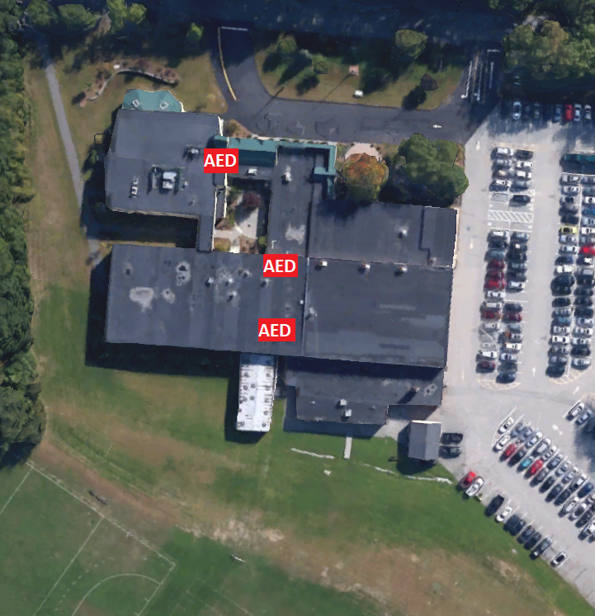

Emergency Action Procedures

Activate the EAP for any of the following injuries:
- Any loss of consciousness
- Possible Spine Injury
- Dislocation, Open Fracture, Displaced Closed Fracture
- Difficulty or absent breathing or pulse
- Uncertainty of if you have a medical emergency
Emergency Personnel:
SSN Athletic Trainer will be on site for select practices and events or in direct communication with coaching staff. Emergencies during practices/games that AT is not present at, EMS should be contacted immediately.

Emergency Procedures:
- Check the scene
  - Is it safe for you to help?
  - What happened?
  - How many victims are there?
  - Can bystanders help?
- Instruct coach or bystander to call 911
-Provide the following information
- Who you are
- General information about the injury or situation
- Where you are (Provide: name, location of downed athlete, address, telephone #, number of individuals injured, type of injury that has occurred, treatment given, specific directions*).
- Any additional information
- *STAY ON THE PHONE, BE THE LAST TO HANG UP*
- Perform emergency CPR/First Aid
  - Check for breathing, level of consciousness, and severe bleeding.
    - If athletic trainer is present, he/she will stay with athlete and provide immediate care.
    - If athletic trainer is not present, most qualified coach (training/certifications) will stay with athlete and provide immediate care.
  - Instruct coach or bystander to GET AED!!
- Designate coach or bystander to control crowd
- Contact the SSN Athletic Trainer if not present on scene
- Contact Athlete’s Parents
- Contact Athletic Administrator
- Meet ambulance and direct to appropriate site
  - Open Appropriate Gates/Doors
  - Designate an individual to "flag down" and direct to scene
  - Control injury site, limit care providers etc.
- Assist AT and/or EMS with care as directed
  - Retrieve Necessary Supplies/Equipment
- A coach should go with the athlete to the hospital or follow in a car if not allowed in ambulance
- Document event and debrief

(Venue Specific): Bishop Brady HS - Athletic Fields
Address: 25 Columbus Ave, Concord, NH 03301
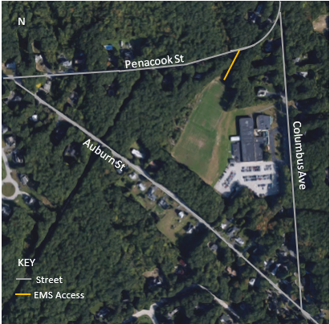
Activate EMS | Call 911. If no cell phone available, use phone in Athletic Director’s office.  **Ask a police officer to make a radio call, when available
AED is located outside the main office, across from gym.
Athletic Trainer, if present, will have portable AED
Script to EMS | “My name is ____. If we get disconnected call (___) ___-____. Respond to Bishop Brady High School located at 25 Columbus Ave, Concord, NH. There are __ (#) people injured. We need emergency medical treatment. Enter through the access road after Columbus Ave on Penacook St. Care is being provided by ____ (State who: Athletic Trainer, Coach, teammate).”  --If able, describe condition and/or type of care to dispatcher.
EAP Team & Roles | MD or PA (if present) will supervise & direct the care of the injured/ill.  AT will provide care under the direction of the physician.  Coach will assist the medical staff as needed; activation of EMS, providing emotional support for the injured athlete, and maintaining order.  Additional persons Delegate to direct EMS, crowd control, etc.
Athlete Info | Coaches should have copies of all consent to treat and emergency information in their travel med kits.
Persons to Notify | Parent/Guardian & School Administration (i.e., AD):  Athletic trainer or school staff will notify above persons. Discuss transportation options to nearest hospital with parent/guardian.
Lightning Shelter | Bishop Brady High School; Fully enclosed cars and busses
Emergency Cold Water Immersion | Call 911. Immediately cool using TACo method. If equipment unavailable, place athlete into locker room showers and run cold water and ice on them.  COOL FIRST, TRANSPORT SECOND! Core temp ≤102

AED is located outside the main office, across from the gym.
Athletic Trainer, if present, will have portable AED

Important Numbers
SSN Athletic Trainer | (203) 948-6345
Athletic Director | (603) 491-6005
Supervising Physician | (603) 224-3368
Local EMS | (603) 225-8650
Local Police | (603) 225-8600
Nearest Hospital (Concord Hospital) | (603) 225-2711

~~EAP should be reviewed and rehearsed annually by Athletic Trainer and appropriate Bishop Brady HS staff members. Any activation of EAP should be documented appropriately (i.e., names, dates, times, and description).

(Venue Specific): Bishop Brady HS – Thomas Hardiman Gymnasium
Address: 25 Columbus Ave, Concord, NH 03301

Activate EMS | Call 911. If no cell phone available, use phone in Athletic Director’s office.  **Ask a police officer to make a radio call, when available
AED is located outside the main office, across from gym.
Athletic Trainer, if present, will have portable AED
Script to EMS | “My name is ____. If we get disconnected call (___) ___-____. Respond to Thomas Hardiman Gym at Bishop Brady High School located at 25 Columbus Ave, Concord, NH. There are __ (#) people injured. We need emergency medical treatment. Enter through the side door connected to the parking lot on the south side of the building off Columbus Ave. Care is being provided by ____ (State who: Athletic Trainer, Coach, teammate).”  --If able, describe condition and/or type of care to dispatcher.
EAP Team & Roles | MD or PA (if present) will supervise & direct the care of the injured/ill.  AT will provide care under the direction of the physician.  Coach will assist the medical staff as needed; activation of EMS, providing emotional support for the injured athlete, and maintaining order.  Additional persons Delegate to direct EMS, crowd control, etc.
Athlete Info | Coaches should have copies of all consent to treat and emergency information in their travel med kits.
Persons to Notify | Parent/Guardian & School Administration (i.e., AD):  Athletic trainer or school staff will notify above persons. Discuss transportation options to nearest hospital with parent/guardian.
Lightning Shelter | Bishop Brady High School
Emergency Cold Water Immersion | Call 911. Place athlete into locker room showers and run cold water and ice on them.  COOL FIRST, TRANSPORT SECOND! Core temp ≤102
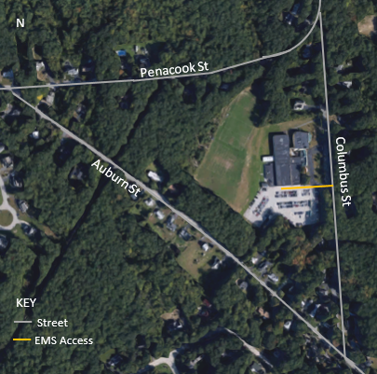

AED is located outside the main office, across from the gym.
Athletic Trainer, if present, will have portable AED

Important Numbers
SSN Athletic Trainer | (203) 948-6345
Athletic Director | (603) 491-6005
Supervising Physician | (603) 224-3368
Local EMS | (603) 225-8650
Local Police | (603) 225-8600
Nearest Hospital (Concord Hospital) | (603) 225-2711

~~EAP should be reviewed and rehearsed annually by Athletic Trainer and appropriate Bishop Brady HS staff members. Any activation of EAP should be documented appropriately (i.e., names, dates, times, and description).

(Venue Specific): Bishop Brady HS – Weight Room
Address: 25 Columbus Ave, Concord, NH 03301

Activate EMS | Call 911. If no cell phone available, use phone in Athletic Director’s office.  **Ask a police officer to make a radio call, when available
AED is located outside the main office, across from gym.
Athletic Trainer, if present, will have portable AED
Script to EMS | “My name is ____. If we get disconnected call (___) ___-____. Respond to Bishop Brady High School weight room located inside the gymnasium located at 25 Columbus Ave, Concord, NH. There are __ (#) people injured. We need emergency medical treatment. Enter through the side door connected to the parking lot on the south side of the building off Columbus Ave. The weight room is located inside the gymnasium to the left of the stage. Care is being provided by ____ (State who: Athletic Trainer, Coach, teammate).”  --If able, describe condition and/or type of care to dispatcher.
EAP Team & Roles | MD or PA (if present) will supervise & direct the care of the injured/ill.  AT will provide care under the direction of the physician.  Coach will assist the medical staff as needed; activation of EMS, providing emotional support for the injured athlete, and maintaining order.  Additional persons Delegate to direct EMS, crowd control, etc.
Athlete Info | Coaches should have copies of all consent to treat and emergency information in their travel med kits.
Persons to Notify | Parent/Guardian & School Administration (i.e., AD):  Athletic trainer or school staff will notify above persons. Discuss transportation options to nearest hospital with parent/guardian.
Lightning Shelter | Bishop Brady High School
Emergency Cold Water Immersion | Call 911. Place athlete into locker room showers and run cold water and ice on them.  COOL FIRST, TRANSPORT SECOND! Core temp ≤102

AED is located outside the main office, across from the gym.
Athletic Trainer, if present, will have portable AED

Important Numbers
SSN Athletic Trainer | (203) 948-6345
Athletic Director | (603) 491-6005
Supervising Physician | (603) 224-3368
Local EMS | (603) 225-8650
Local Police | (603) 225-8600
Nearest Hospital (Concord Hospital) | (603) 225-2711

~~EAP should be reviewed and rehearsed annually by Athletic Trainer and appropriate Bishop Brady HS staff members. Any activation of EAP should be documented appropriately (i.e., names, dates, times, and description).

(Venue Specific): Memorial Field
Address: 70 S. Fruit St, Concord, NH 03301

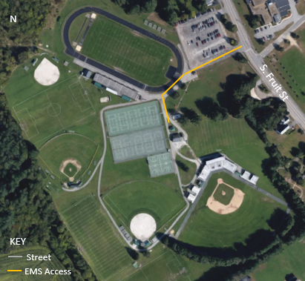
Activate EMS | Call 911. If no cell phone available, run to house closest on street to ask.  **Ask a police officer to make a radio call, when available
NO AED ONSITE – RELY ON EMS
Athletic Trainer, if present, will have portable AED
Script to EMS | “My name is ____. If we get disconnected call (___) ___-____. Respond to Memorial Field located at 70 S. Fruit St, Concord, NH. There are __ (#) people injured. We need emergency medical treatment. Enter through the access road at the bottom left of the parking lot off S. Fruit St. Care is being provided by ____ (State who: Athletic Trainer, Coach, teammate).”  --If able, describe condition and/or type of care to dispatcher.
EAP Team & Roles | MD or PA (if present) will supervise & direct the care of the injured/ill.  AT will provide care under the direction of the physician.  Coach will assist the medical staff as needed; activation of EMS, providing emotional support for the injured athlete, and maintaining order.  Additional persons Delegate to direct EMS, crowd control, etc.
Athlete Info | Coaches should have copies of all consent to treat and emergency information in their travel med kits.
Persons to Notify | Parent/Guardian & School Administration (i.e., AD):  Athletic trainer or school staff will notify above persons. Discuss transportation options to nearest hospital with parent/guardian.
Lightning Shelter | Fully enclosed cars and busses; Concession stand/other fully enclosed structure with plumbing/wiring if unlocked.
Emergency Cold Water Immersion | Call 911. Immediately cool using TACO method. Tarp located with coaches or with athletic trainer if on-site. COOL FIRST, TRANSPORT SECOND! Core temp ≤102

NO AED ONSITE – if trained, perform CPR until EMS arrives.
Athletic Trainer, if present, will have portable AED

Important Numbers
SSN Athletic Trainer | (203) 948-6345
Athletic Director | (603) 491-6005
Supervising Physician | (603) 224-3368
Local EMS | (603) 225-8650
Local Police | (603) 225-8600
Nearest Hospital (Concord Hospital) | (603) 225-2711

~~EAP should be reviewed and rehearsed annually by Athletic Trainer and appropriate Bishop Brady HS staff members. Any activation of EAP should be documented appropriately (i.e., names, dates, times, and description).

(Venue Specific): State Hospital/S. Fruit Street Fields
Address: 121 S. Fruit St, Concord, NH 03301
(Next to Philbrook Building)

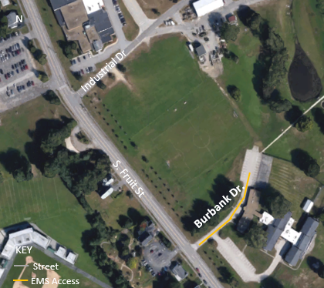
Activate EMS | Call 911. If no cell phone available, run to house closest on street to ask.  **Ask a police officer to make a radio call, when available
AED located inside Philbrook Building – Enter through main door and request AED
If building is closed/locked, rely on EMS
Athletic Trainer, if present, will have portable AED
Script to EMS | “My name is ____. If we get disconnected call (___) ___-____. Respond to State Hospital Fields located at 121 S. Fruit St, Concord, NH. There are __ (#) people injured. We need emergency medical treatment. Enter through Burbank Drive off S. Fruit St. Care is being provided by ____ (State who: Athletic Trainer, Coach, teammate).”  --If able, describe condition and/or type of care to dispatcher.
EAP Team & Roles | MD or PA (if present) will supervise & direct the care of the injured/ill.  AT will provide care under the direction of the physician.  Coach will assist the medical staff as needed; activation of EMS, providing emotional support for the injured athlete, and maintaining order.  Additional persons Delegate to direct EMS, crowd control, etc.
Athlete Info | Coaches should have copies of all consent to treat and emergency information in their travel med kits.
Persons to Notify | Parent/Guardian & School Administration (i.e., AD):  Athletic trainer or school staff will notify above persons. Discuss transportation options to nearest hospital with parent/guardian.
Lightning Shelter | Fully enclosed cars and busses; Philbrook building if accessible.
Emergency Cold Water Immersion | Call 911. Immediately cool using TACO method. Tarp located with coaches or with athletic trainer if on-site. COOL FIRST, TRANSPORT SECOND! Core temp ≤102

AED LOCATED INSIDE PHILBROOK BUILDING – If closed/locked – rely on EMS
Athletic Trainer, if present, will have portable AED.

Important Numbers
SSN Athletic Trainer | (203) 948-6345
Athletic Director | (603) 491-6005
Supervising Physician | (603) 224-3368
Local EMS | (603) 225-8650
Local Police | (603) 225-8600
Nearest Hospital (Concord Hospital) | (603) 225-2711

~~EAP should be reviewed and rehearsed annually by Athletic Trainer and appropriate Bishop Brady HS staff members. Any activation of EAP should be documented appropriately (i.e., names, dates, times, and description).

(Venue Specific): Shaker Road School – Soccer Fields
Address: 90 West Portsmouth St, Concord, NH 03301

Activate EMS | Call 911. If no cell phone available, run to house closest on street to ask.  **Ask a police officer to make a radio call, when available
NO AED ONSITE – RELY ON EMS
Athletic Trainer, if present, will have portable AED
Script to EMS | “My name is ____. If we get disconnected call (___) ___-____. Respond to Shaker Road School, River Soccer Fields located at 90 West Portsmouth St., Concord, NH. There are __ (#) people injured. We need emergency medical treatment. Enter the parking lot on your left at the end of the dirt road. Care is being provided by ____ (State who: Athletic Trainer, Coach, teammate).”  --If able, describe condition and/or type of care to dispatcher.
EAP Team & Roles | MD or PA (if present) will supervise & direct the care of the injured/ill.  AT will provide care under the direction of the physician.  Coach will assist the medical staff as needed; activation of EMS, providing emotional support for the injured athlete, and maintaining order.  Additional persons Delegate to direct EMS, crowd control, etc.
Athlete Info | Coaches should have copies of all consent to treat and emergency information in their travel med kits.
Persons to Notify | Parent/Guardian & School Administration (i.e., AD):  Athletic trainer or school staff will notify above persons. Discuss transportation options to nearest hospital with parent/guardian.
Lightning Shelter | Fully enclosed cars and busses.
Emergency Cold Water Immersion | Call 911. Immediately cool using TACO method. Tarp located with coaches or with athletic trainer if on-site. COOL FIRST, TRANSPORT SECOND! Core temp ≤102
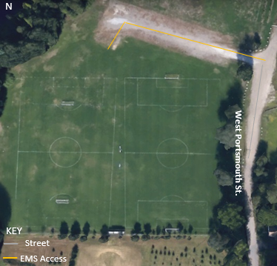

NO AED ONSITE – if trained, perform CPR until EMS arrives.
Athletic Trainer, if present, will have portable AED

Important Numbers
SSN Athletic Trainer | (203) 948-6345
Athletic Director | (603) 491-6005
Supervising Physician | (603) 224-3368
Local EMS | (603) 225-8650
Local Police | (603) 225-8600
Nearest Hospital (Concord Hospital) | (603) 225-2711

~~EAP should be reviewed and rehearsed annually by Athletic Trainer and appropriate Bishop Brady HS staff members. Any activation of EAP should be documented appropriately (i.e., names, dates, times, and description).

(Venue Specific): NHTI Soccer Fields 2 & 3
Address: 31 College Dr, Concord, NH 03301

Activate EMS | Call 911.  **Ask a police officer to make a radio call, when available
NO AED ONSITE – RELY ON EMS
Athletic Trainer, if present, will have portable AED
Script to EMS | “My name is ____. If we get disconnected call (___) ___-____. Respond to NHTI Soccer Field #2 & #3 located at 31 College Drive, Concord, NH. There are __ (#) people injured. We need emergency medical treatment. Enter through the access at the end of College Drive. Care is being provided by ____ (State who: Athletic Trainer, Coach, teammate).”  --If able, describe condition and/or type of care to dispatcher.
EAP Team & Roles | MD or PA (if present) will supervise & direct the care of the injured/ill.  AT will provide care under the direction of the physician.  Coach will assist the medical staff as needed; activation of EMS, providing emotional support for the injured athlete, and maintaining order.  Additional persons Delegate to direct EMS, crowd control, etc.
Athlete Info | Coaches should have copies of all consent to treat and emergency information in their travel med kits.
Persons to Notify | Parent/Guardian & School Administration (i.e., AD):  Athletic trainer or school staff will notify above persons. Discuss transportation options to nearest hospital with parent/guardian.
Lightning Shelter | Fully enclosed cars and busses; NHTI building if accessible.
Emergency Cold Water Immersion | Call 911. Immediately cool using TACO method. Tarp located with coaches or with athletic trainer if on-site. COOL FIRST, TRANSPORT SECOND! Core temp ≤102
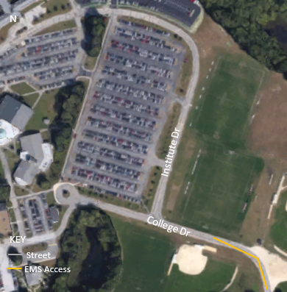

NO AED ONSITE – if trained, perform CPR until EMS arrives.
Athletic Trainer, if present, will have portable AED
Important Numbers
SSN Athletic Trainer | (203) 948-6345
Athletic Director | (603) 491-6005
Supervising Physician | (603) 224-3368
Local EMS | (603) 225-8650
Local Police | (603) 225-8600
Nearest Hospital (Concord Hospital) | (603) 225-2711

~~EAP should be reviewed and rehearsed annually by Athletic Trainer and appropriate Bishop Brady HS staff members. Any activation of EAP should be documented appropriately (i.e., names, dates, times, and description).

(Venue Specific): NHTI Little Hall Commons
Address: 31 College Dr, Concord, NH 03301

Activate EMS | Call 911.  **Ask a police officer to make a radio call, when available
NO AED ONSITE – RELY ON EMS
Athletic Trainer, if present, will have portable AED
Script to EMS | “My name is ____. If we get disconnected call (___) ___-____. Respond to NHTI Little Hall Commons located at 31 College Drive, Concord, NH. There are __ (#) people injured. We need emergency medical treatment. Enter through the access at the end of College Dr. Care is being provided by ____ (State who: Athletic Trainer, Coach, teammate).”  --If able, describe condition and/or type of care to dispatcher.
EAP Team & Roles | MD or PA (if present) will supervise & direct the care of the injured/ill.  AT will provide care under the direction of the physician.  Coach will assist the medical staff as needed; activation of EMS, providing emotional support for the injured athlete, and maintaining order.  Additional persons Delegate to direct EMS, crowd control, etc.
Athlete Info | Coaches should have copies of all consent to treat and emergency information in their travel med kits.
Persons to Notify | Parent/Guardian & School Administration (i.e., AD):  Athletic trainer or school staff will notify above persons. Discuss transportation options to nearest hospital with parent/guardian.
Lightning Shelter | Fully enclosed cars and busses; NHTI building if accessible.
Emergency Cold Water Immersion | Call 911. Immediately cool using TACO method. Tarp located with coaches or with athletic trainer if on-site. COOL FIRST, TRANSPORT SECOND! Core temp ≤102
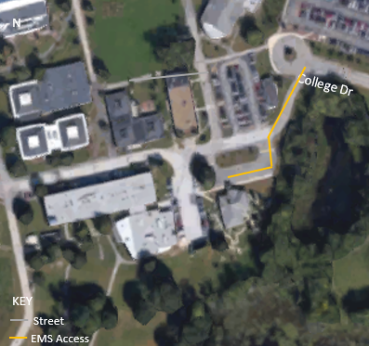

NO AED ONSITE – if trained, perform CPR until EMS arrives.
Athletic Trainer, if present, will have portable AED

Important Numbers
SSN Athletic Trainer | (203) 948-6345
Athletic Director | (603) 491-6005
Supervising Physician | (603) 224-3368
Local EMS | (603) 225-8650
Local Police | (603) 225-8600
Nearest Hospital (Concord Hospital) | (603) 225-2711

~~EAP should be reviewed and rehearsed annually by Athletic Trainer and appropriate Bishop Brady HS staff members. Any activation of EAP should be documented appropriately (i.e., names, dates, times, and description).

(Venue Specific): Beaver Meadow Golf Course
Address: 1 Beaver Meadow Dr, Concord, NH 03301

Activate EMS | Call 911. If no cell phone available, use phone in club house  **Ask a police officer to make a radio call, when available
NO AED ONSITE – RELY ON EMS
Athletic Trainer, if present, will have portable AED
Script to EMS | “My name is ____. If we get disconnected call (___) ___-____. Respond to Beaver Meadow Golf Course located at 1 Beaver Meadow Dr, Concord, NH. There are __ (#) people injured. We need emergency medical treatment. Enter on Beaver Meadow Dr off Sewalls Falls Rd. Care is being provided by ____ (State who: Athletic Trainer, Coach, teammate).”  --If able, describe condition and/or type of care to dispatcher.
EAP Team & Roles | MD or PA (if present) will supervise & direct the care of the injured/ill.  AT will provide care under the direction of the physician.  Coach will assist the medical staff as needed; activation of EMS, providing emotional support for the injured athlete, and maintaining order.  Additional persons Delegate to direct EMS, crowd control, etc.
Athlete Info | Coaches should have copies of all consent to treat and emergency information in their travel med kits.
Persons to Notify | Parent/Guardian & School Administration (i.e., AD):  Athletic trainer or school staff will notify above persons. Discuss transportation options to nearest hospital with parent/guardian.
Lightning Shelter | Club house if accessible; Fully enclosed cars and busses
Emergency Cold Water Immersion | Call 911. Immediately cool using TACO method. Tarp located with coaches or with athletic trainer if on-site. COOL FIRST, TRANSPORT SECOND! Core temp ≤102
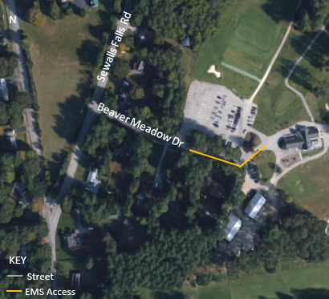

NO AED ONSITE – if trained, perform CPR until EMS arrives.
Athletic Trainer, if present, will have portable AED

Important Numbers
SSN Athletic Trainer | (203) 948-6345
Athletic Director | (603) 491-6005
Supervising Physician | (603) 224-3368
Local EMS | (603) 225-8650
Local Police | (603) 225-8600
Nearest Hospital (Concord Hospital) | (603) 225-2711

~~EAP should be reviewed and rehearsed annually by Athletic Trainer and appropriate Bishop Brady HS staff members. Any activation of EAP should be documented appropriately (i.e., names, dates, times, and description).

(Venue Specific): Tri-Town Ice Arena
Address: 311 W. River Rd, Hooksett, NH 03106

Activate EMS | Call 911. If no cell phone available, use phone in main office of arena  **Ask a police officer to make a radio call, when available
AED located in the main lobby on wall
Athletic Trainer, if present, will have portable AED
Script to EMS | “My name is ____. If we get disconnected call (___) ___-____. Respond to Tri Town Ice Arena located at 311 W. River Road, Hooksett, NH. There are __ (#) people injured. We need emergency medical treatment. Enter through the main entrance at front of the building. Care is being provided by ____ (State who: Athletic Trainer, Coach, teammate).”  --If able, describe condition and/or type of care to dispatcher.
EAP Team & Roles | MD or PA (if present) will supervise & direct the care of the injured/ill.  AT will provide care under the direction of the physician.  Coach will assist the medical staff as needed; activation of EMS, providing emotional support for the injured athlete, and maintaining order.  Additional persons Delegate to direct EMS, crowd control, etc.
Athlete Info | Coaches should have copies of all consent to treat and emergency information in their travel med kits.
Persons to Notify | Parent/Guardian & School Administration (i.e., AD):  Athletic trainer or school staff will notify above persons. Discuss transportation options to nearest hospital with parent/guardian.
Lightning Shelter | Tri-Town Ice Arena; Fully enclosed cars and busses
Emergency Cold Water Immersion | Call 911. Place athlete into locker room showers and run cold water and ice on them.  COOL FIRST, TRANSPORT SECOND! Core temp ≤102
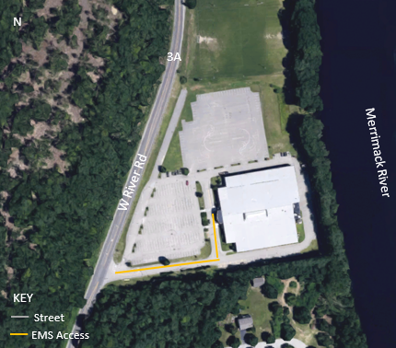

AED located in the main lobby on wall.
Athletic Trainer, if present, will have portable AED

Important Numbers
SSN Athletic Trainer | (203) 948-6345
Athletic Director | (603) 491-6005
Supervising Physician | (603) 224-3368
Local EMS (Hooksett) | (603) 623-7272
Local Police (Hooksett) | (603) 624-1560
Nearest Hospital (CMC - Manchester) | (603) 668-3545

~~EAP should be reviewed and rehearsed annually by Athletic Trainer and appropriate Bishop Brady HS staff members. Any activation of EAP should be documented appropriately (i.e., names, dates, times, and description).

(Venue Specific): Everett Arena
Address: 15 Loudon Road, Concord, NH 03301

Activate EMS | Call 911. If no cell phone available, use phone in main office of arena.  **Ask a police officer to make a radio call, when available
NO AED ONSITE – RELY ON EMS
Athletic Trainer, if present, will have portable AED
Script to EMS | “My name is ____. If we get disconnected call (___) ___-____. Respond to Everett Arena located at 15 Loudon Road, Concord, NH. There are __ (#) people injured. We need emergency medical treatment. Enter through the main entrance of the arena. Care is being provided by ____ (State who: Athletic Trainer, Coach, teammate).”  --If able, describe condition and/or type of care to dispatcher.
EAP Team & Roles | MD or PA (if present) will supervise & direct the care of the injured/ill.  AT will provide care under the direction of the physician.  Coach will assist the medical staff as needed; activation of EMS, providing emotional support for the injured athlete, and maintaining order.  Additional persons Delegate to direct EMS, crowd control, etc.
Athlete Info | Coaches should have copies of all consent to treat and emergency information in their travel med kits.
Persons to Notify | Parent/Guardian & School Administration (i.e., AD):  Athletic trainer or school staff will notify above persons. Discuss transportation options to nearest hospital with parent/guardian.
Lightning Shelter | Everett Arena; Fully enclosed cars and busses
Emergency Cold Water Immersion | Call 911. Place athlete into locker room showers and run cold water and ice on them.  COOL FIRST, TRANSPORT SECOND! Core temp ≤102
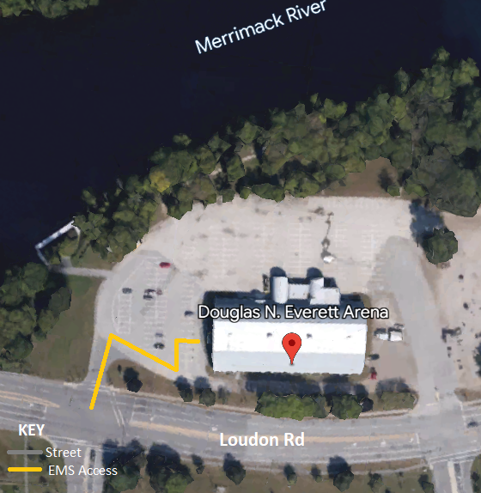

NO AED ONSITE – if trained, perform CPR until EMS arrives.
Athletic Trainer, if present, will have portable AED

Important Numbers
SSN Athletic Trainer | (203) 948-6345
Athletic Director | (603) 491-6005
Supervising Physician | (603) 224-3368
Local EMS | (603) 225-8650
Local Police | (603) 225-8600
Nearest Hospital (Concord Hospital) | (603) 225-2711

~~EAP should be reviewed and rehearsed annually by Athletic Trainer and appropriate Bishop Brady HS staff members. Any activation of EAP should be documented appropriately (i.e., names, dates, times, and description).

(Venue Specific): JFK Coliseum
Address: 303 Beech St, Manchester, NH 03103

Activate EMS | Call 911. If no cell phone available, use phone in main office of arena  **Ask a police officer to make a radio call, when available
AED located in the main office on the East side of the building
Athletic Trainer, if present, will have portable AED
Script to EMS | “My name is ____. If we get disconnected call (___) ___-____. Respond to JFK Coliseum located at 303 Beech St, Manchester, NH. There are __ (#) people injured. We need emergency medical treatment. Enter through the EAST (Maple St) OR WEST (Beech St) entrance. Care is being provided by ____ (State who: Athletic Trainer, Coach, teammate).”  --If able, describe condition and/or type of care to dispatcher.
EAP Team & Roles | MD or PA (if present) will supervise & direct the care of the injured/ill.  AT will provide care under the direction of the physician.  Coach will assist the medical staff as needed; activation of EMS, providing emotional support for the injured athlete, and maintaining order.  Additional persons Delegate to direct EMS, crowd control, etc.
Athlete Info | Coaches should have copies of all consent to treat and emergency information in their travel med kits.
Persons to Notify | Parent/Guardian & School Administration (i.e., AD):  Athletic trainer or school staff will notify above persons. Discuss transportation options to nearest hospital with parent/guardian.
Lightning Shelter | JFK Coliseum; Fully enclosed cars and busses
Emergency Cold Water Immersion | Call 911. Place athlete into locker room showers and run cold water and ice on them.  COOL FIRST, TRANSPORT SECOND! Core temp ≤102
SSN Athletic Trainer | (203) 948-6345
Athletic Director | (603) 491-6005
Supervising Physician | (603) 224-3368
Local EMS (Manchester) | (603) 669-7707
Local Police (Manchester) | (603) 225-8600
Nearest Hospital (Elliot Hospital - Manchester) | (603) 663-2533
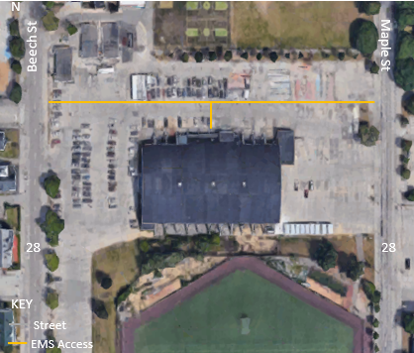

AED located in the main office on the East side of the building.
Athletic Trainer, if present, will have portable AED

Important Numbers

~~EAP should be reviewed and rehearsed annually by Athletic Trainer and appropriate Bishop Brady HS staff members. Any activation of EAP should be documented appropriately (i.e., names, dates, times, and description).

(Venue Specific): NEC Lee Clement Arena
Address: 38 Grove St, Henniker, NH 03242

Activate EMS | Call 911. If no cell phone available, use phone in main office of arena.  **Ask a police officer to make a radio call, when available
AED located in the main lobby.
Athletic Trainer, if present, will have portable AED
Script to EMS | “My name is ____. If we get disconnected call (___) ___-____. Respond to NEC Lee Clement Arena located at 38 Grove St. Henniker, NH. There are __ (#) people injured. We need emergency medical treatment. Enter through the main entrance at the front of building off Grove St. Care is being provided by ____ (State who: Athletic Trainer, Coach, teammate).”  --If able, describe condition and/or type of care to dispatcher.
EAP Team & Roles | MD or PA (if present) will supervise & direct the care of the injured/ill.  AT will provide care under the direction of the physician.  Coach will assist the medical staff as needed; activation of EMS, providing emotional support for the injured athlete, and maintaining order.  Additional persons Delegate to direct EMS, crowd control, etc.
Athlete Info | Coaches should have copies of all consent to treat and emergency information in their travel med kits.
Persons to Notify | Parent/Guardian & School Administration (i.e., AD):  Athletic trainer or school staff will notify above persons. Discuss transportation options to nearest hospital with parent/guardian.
Lightning Shelter | NEC Lee Clement Arena; Fully enclosed cars and busses
Emergency Cold Water Immersion | Call 911. Place athlete into locker room showers and run cold water and ice on them.  COOL FIRST, TRANSPORT SECOND! Core temp ≤102
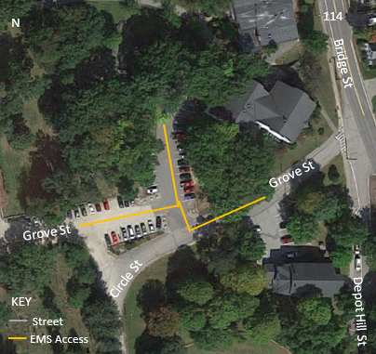

AED located in the main lobby.
Athletic Trainer, if present, will have portable AED

Important Numbers
SSN Athletic Trainer | (203) 948-6345
Athletic Director | (603) 491-6005
Supervising Physician | (603) 224-3368
Local EMS (Henniker) | (603) 428-7552
Local Police (Henniker) | (603) 428-3213
Nearest Hospital (Concord Hospital) | (603) 225-2711

~~EAP should be reviewed and rehearsed annually by Athletic Trainer and appropriate Bishop Brady HS staff members. Any activation of EAP should be documented appropriately (i.e., names, dates, times, and description).

(Venue Specific): Health Club of Concord
Address: 10 Garvins Falls Rd, Concord, NH 03301

Activate EMS | Call 911. If no cell phone available, use phone at front desk.  **Ask a police officer to make a radio call, when available.
AED located at front desk.
Athletic Trainer, if present, will have portable AED
Script to EMS | “My name is ____. If we get disconnected call (___) ___-____. Respond to Health Club of Concord located at 10 Garvins Falls Rd, Concord NH. There are __ (#) people injured. We need emergency medical treatment. Enter at the main entrance at the front of the building. Care is being provided by ____ (State who: Athletic Trainer, Coach, teammate).”  --If able, describe condition and/or type of care to dispatcher.
EAP Team & Roles | MD or PA (if present) will supervise & direct the care of the injured/ill.  AT will provide care under the direction of the physician.  Coach will assist the medical staff as needed; activation of EMS, providing emotional support for the injured athlete, and maintaining order.  Additional persons Delegate to direct EMS, crowd control, etc.
Athlete Info | Coaches should have copies of all consent to treat and emergency information in their travel med kits.
Persons to Notify | Parent/Guardian & School Administration (i.e., AD):  Athletic trainer or school staff will notify above persons. Discuss transportation options to nearest hospital with parent/guardian.
Lightning Shelter | Health Club of Concord; Fully enclosed cars and busses
Emergency Cold Water Immersion | Call 911. Place athlete into locker room showers and run cold water and ice on them.  COOL FIRST, TRANSPORT SECOND! Core temp ≤102
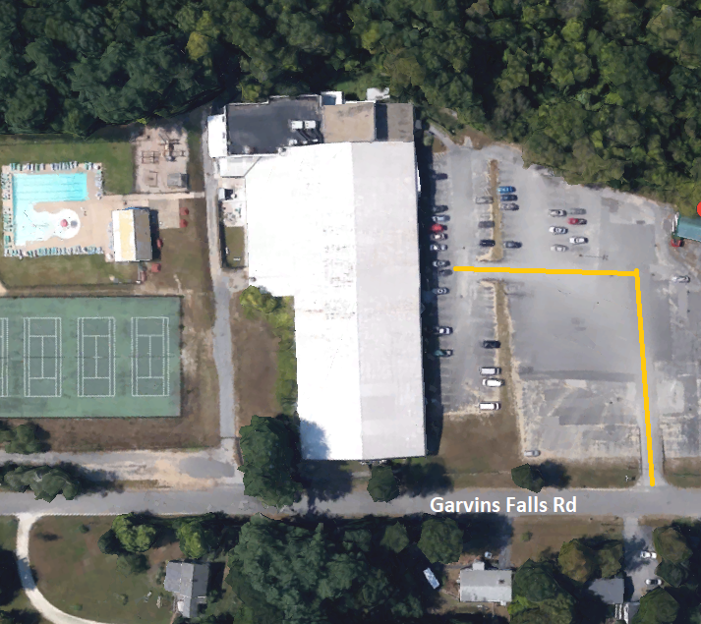

AED located at front desk.
Athletic Trainer, if present, will have portable AED

Important Numbers
SSN Athletic Trainer | (203) 948-6345
Athletic Director | (603) 491-6005
Supervising Physician | (603) 224-3368
Local EMS | (603) 225-8650
Local Police | (603) 225-8600
Nearest Hospital (Concord Hospital) | (603) 225-2711

~~EAP should be reviewed and rehearsed annually by Athletic Trainer and appropriate Bishop Brady HS staff members. Any activation of EAP should be documented appropriately (i.e., names, dates, times, and description).

(Venue Specific): YMCA of Concord
Address: 15 N. State St, Concord, NH 03301

Activate EMS | Call 911. If no cell phone available, use phone in main lobby  **Ask a police officer to make a radio call, when available
AED is located at the front desk.
Athletic Trainer, if present, will have portable AED
Script to EMS | “My name is ____. If we get disconnected call (___) ___-____. Respond to YMCA of Concord located at 15 N. State Street, Concord, NH. There are __ (#) people injured. We need emergency medical treatment. Enter through main entrance off N. State St. Care is being provided by ____ (State who: Athletic Trainer, Coach, teammate).”  --If able, describe condition and/or type of care to dispatcher.
EAP Team & Roles | MD or PA (if present) will supervise & direct the care of the injured/ill.  AT will provide care under the direction of the physician.  Coach will assist the medical staff as needed; activation of EMS, providing emotional support for the injured athlete, and maintaining order.  Additional persons Delegate to direct EMS, crowd control, etc.
Athlete Info | Coaches should have copies of all consent to treat and emergency information in their travel med kits.
Persons to Notify | Parent/Guardian & School Administration (i.e., AD):  Athletic trainer or school staff will notify above persons. Discuss transportation options to nearest hospital with parent/guardian.
Lightning Shelter | YMCA of Concord; Fully enclosed cars and busses
Emergency Cold Water Immersion | Call 911. Place athlete into locker room showers and run cold water and ice on them.  COOL FIRST, TRANSPORT SECOND! Core temp ≤102
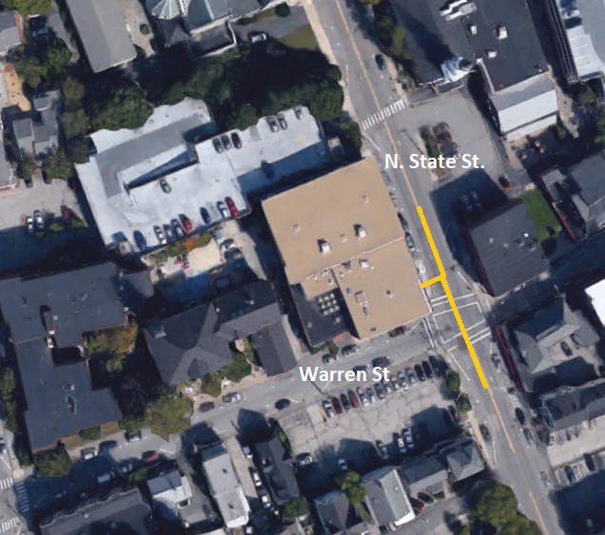

AED located at front desk.
Athletic Trainer, if present, will have portable AED

Important Numbers
SSN Athletic Trainer | (203) 948-6345
Athletic Director | (603) 491-6005
Supervising Physician | (603) 224-3368
Local EMS | (603) 225-8650
Local Police | (603) 225-8600
Nearest Hospital (Concord Hospital) | (603) 225-2711

~~EAP should be reviewed and rehearsed annually by Athletic Trainer and appropriate Bishop Brady HS staff members. Any activation of EAP should be documented appropriately (i.e., names, dates, times, and description).

(Venue Specific): Pats Peak Ski Area
Address: 686 Flanders Rd, Henniker, NH 03242

Activate EMS | Contact Ski Patrol. They will notify 911. If no cell phone available, use phone in main lodge or tell nearest lift attendant.
AED is located at Guest Services, next to the stairs, on the 1st floor.
Athletic Trainer, if present, will have portable AED
Script to EMS | *NOTIFY SKI PATROL* - they contact 911  “My name is ____. If we get disconnected call (___) ___-____. Respond to Pat’s Peak Ski Mountain located at 686 Flanders Road, Henniker, NH. There are __ (#) people injured. We need emergency medical treatment. Enter through the access road off Flanders Rd. Care is being provided by ____ (State who: Athletic Trainer, Coach, teammate).”  --If able, describe condition and/or type of care to dispatcher.
EAP Team & Roles | MD or PA (if present) will supervise & direct the care of the injured/ill.  AT will provide care under the direction of the physician.  Coach will assist the medical staff as needed; activation of EMS, providing emotional support for the injured athlete, and maintaining order.  Additional persons Delegate to direct EMS, crowd control, etc.
Athlete Info | Coaches should have copies of all consent to treat and emergency information in their travel med kits.
Persons to Notify | Parent/Guardian & School Administration (i.e., AD):  Athletic trainer or school staff will notify above persons. Discuss transportation options to nearest hospital with parent/guardian.
Lightning Shelter | Main Lodge; Fully enclosed cars and busses
Emergency Cold Water Immersion | Call 911. Immediately cool using TACO method. Tarp located with coaches or with athletic trainer if on-site.  COOL FIRST, TRANSPORT SECOND! Core temp ≤102
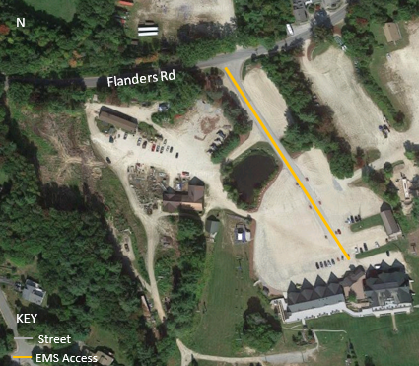

AED located at Guest Services, next to the stairs, on 1st floor.
Athletic Trainer, if present, will have portable AED

Important Numbers
SSN Athletic Trainer | (203) 948-6345
Athletic Director | (603) 491-6005
Supervising Physician | (603) 224-3368
Local EMS (Henniker) | (603) 428-7552
Local Police (Henniker) | (603) 428-3213
Nearest Hospital (Concord Hospital) | (603) 225-2711

~~EAP should be reviewed and rehearsed annually by Athletic Trainer and appropriate Bishop Brady HS staff members. Any activation of EAP should be documented appropriately (i.e., names, dates, times, and description).

(Venue Specific): Rollins Park – Softball Field
Address: 111 Broadway, Concord, NH 03301

Activate EMS | Call 911. If no cell phone available, run to house closest on street to ask.  **Ask a police officer to make a radio call, when available.
NO AED ONSITE – RELY ON EMS
Athletic Trainer, if present, will have portable AED
Script to EMS | “My name is ____. If we get disconnected call (___) ___-____. Respond to Rollins Park softball field located at 111 Broadway, Concord, NH. There are __ (#) people injured. We need emergency medical treatment. Enter through the access road off Broadway. Care is being provided by ____ (State who: Athletic Trainer, Coach, teammate).”  --If able, describe condition and/or type of care to dispatcher.
EAP Team & Roles | MD or PA (if present) will supervise & direct the care of the injured/ill.  AT will provide care under the direction of the physician.  Coach will assist the medical staff as needed; activation of EMS, providing emotional support for the injured athlete, and maintaining order.  Additional persons Delegate to direct EMS, crowd control, etc.
Athlete Info | Coaches should have copies of all consent to treat and emergency information in their travel med kits.
Persons to Notify | Parent/Guardian & School Administration (i.e., AD):  Athletic trainer or school staff will notify above persons. Discuss transportation options to nearest hospital with parent/guardian.
Lightning Shelter | Fully Enclosed Cars and Busses; Dugouts are NOT adequate shelters
Emergency Cold Water Immersion | Call 911. Immediately cool using TACO method. Tarp located with coaches or with athletic trainer if on-site.  COOL FIRST, TRANSPORT SECOND! Core temp ≤102
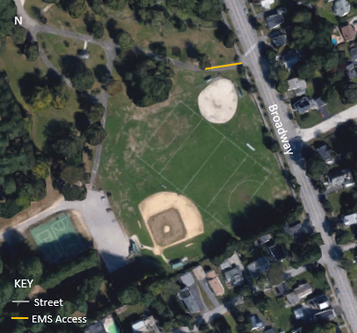

NO AED ONSITE – if trained, perform CPR until EMS arrives.
Athletic Trainer, if present, will have portable AED

Important Numbers
SSN Athletic Trainer | (203) 948-6345
Athletic Director | (603) 491-6005
Supervising Physician | (603) 224-3368
Local EMS | (603) 225-8650
Local Police | (603) 225-8600
Nearest Hospital (Concord Hospital) | (603) 225-2711

~~EAP should be reviewed and rehearsed annually by Athletic Trainer and appropriate Bishop Brady HS staff members. Any activation of EAP should be documented appropriately (i.e., names, dates, times, and description).

(Venue Specific): Rollins Park – Baseball Field
Address: 33 Bow St, Concord, NH 03301

Activate EMS | Call 911. If no cell phone available, run to house closest on street to ask.  **Ask a police officer to make a radio call, when available.
NO AED ONSITE – RELY ON EMS
Athletic Trainer, if present, will have portable AED
Script to EMS | “My name is ____. If we get disconnected call (___) ___-____. Respond to Rollins Park baseball field located at 33 Bow St, Concord, NH. There are __ (#) people injured. We need emergency medical treatment. Enter through the parking lot entrance off Bow St. Care is being provided by ____ (State who: Athletic Trainer, Coach, teammate).”  --If able, describe condition and/or type of care to dispatcher.
EAP Team & Roles | MD or PA (if present) will supervise & direct the care of the injured/ill.  AT will provide care under the direction of the physician.  Coach will assist the medical staff as needed; activation of EMS, providing emotional support for the injured athlete, and maintaining order.  Additional persons Delegate to direct EMS, crowd control, etc.
Athlete Info | Coaches should have copies of all consent to treat and emergency information in their travel med kits.
Persons to Notify | Parent/Guardian & School Administration (i.e., AD):  Athletic trainer or school staff will notify above persons. Discuss transportation options to nearest hospital with parent/guardian.
Lightning Shelter | Fully Enclosed Cars and Busses; Dugouts are NOT adequate shelters
Emergency Cold Water Immersion | Call 911. Immediately cool using TACO method. Tarp located with coaches or with athletic trainer if on-site.  COOL FIRST, TRANSPORT SECOND! Core temp ≤102
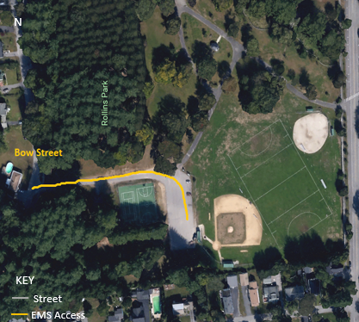

NO AED ONSITE – if trained, perform CPR until EMS arrives.
Athletic Trainer, if present, will have portable AED

Important Numbers
SSN Athletic Trainer | (203) 948-6345
Athletic Director | (603) 491-6005
Supervising Physician | (603) 224-3368
Local EMS | (603) 225-8650
Local Police | (603) 225-8600
Nearest Hospital (Concord Hospital) | (603) 225-2711

~~EAP should be reviewed and rehearsed annually by Athletic Trainer and appropriate Bishop Brady HS staff members. Any activation of EAP should be documented appropriately (i.e., names, dates, times, and description).

(Venue Specific): Merrill Park Tennis Courts
Address: 27 Eastman St, Concord, NH 03303

Activate EMS | Call 911. If no cell phone available, run to house closest on street to ask.  **Ask a police officer to make a radio call, when available.
NO AED ONSITE – RELY ON EMS
Athletic Trainer, if present, will have portable AED
Script to EMS | “My name is ____. If we get disconnected call (___) ___-____. Respond to Merrill Park Tennis Courts located at 27 Eastman St, Concord NH. There are __ (#) people injured. We need emergency medical treatment. Enter the parking lot off Eastman St. Care is being provided by ____ (State who: Athletic Trainer, Coach, teammate).”  --If able, describe condition and/or type of care to dispatcher.
EAP Team & Roles | MD or PA (if present) will supervise & direct the care of the injured/ill.  AT will provide care under the direction of the physician.  Coach will assist the medical staff as needed; activation of EMS, providing emotional support for the injured athlete, and maintaining order.  Additional persons Delegate to direct EMS, crowd control, etc.
Athlete Info | Coaches should have copies of all consent to treat and emergency information in their travel med kits.
Persons to Notify | Parent/Guardian & School Administration (i.e., AD):  Athletic trainer or school staff will notify above persons. Discuss transportation options to nearest hospital with parent/guardian.
Lightning Shelter | Fully Enclosed Cars and Busses
Emergency Cold Water Immersion | Call 911. Immediately cool using TACO method. Tarp located with coaches or with athletic trainer if on-site.  COOL FIRST, TRANSPORT SECOND! Core temp ≤102
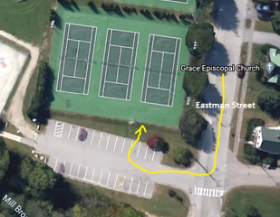

NO AED ONSITE – if trained, perform CPR until EMS arrives.
Athletic Trainer, if present, will have portable AED

Important Numbers
SSN Athletic Trainer | (203) 948-6345
Athletic Director | (603) 491-6005
Supervising Physician | (603) 224-3368
Local EMS | (603) 225-8650
Local Police | (603) 225-8600
Nearest Hospital (Concord Hospital) | (603) 225-2711

~~EAP should be reviewed and rehearsed annually by Athletic Trainer and appropriate Bishop Brady HS staff members. Any activation of EAP should be documented appropriately (i.e., names, dates, times, and description).

(Venue Specific): Merrimack Valley HS – Track Complex
Address: 14 Allen St, Penacook, NH
(Intersection of Allen St and Community Dr)

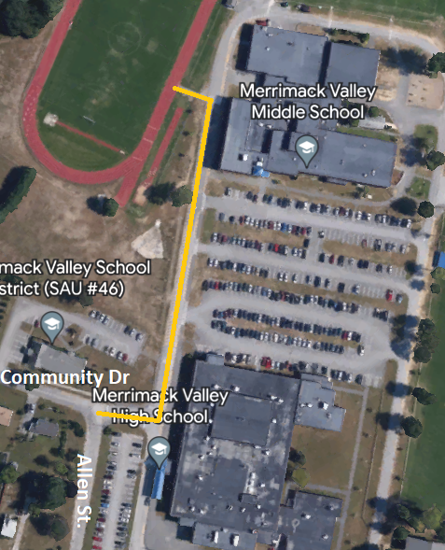
Activate EMS | Call 911. If no cell phone available, use phone in MVMS or MVHS main office if accessible. If schools are locked, run to house closest on street to ask.  **Ask a police officer to make a radio call, when available.
AED located in middle school front entry/hallway
MVHS/BBHS Athletic Trainer, if present, will have portable AED
Script to EMS | “My name is ____. If we get disconnected call (___) ___-____. Respond to Merrimack Valley High School Track Complex located at 14 Allen St, Penacook, NH. There are __ (#) people injured. We need emergency medical treatment. Enter the complex through the access road at the corner of Allen St and Community Drive. Care is being provided by ____ (State who: Athletic Trainer, Coach, teammate).”  --If able, describe condition and/or type of care to dispatcher.
EAP Team & Roles | MD or PA (if present) will supervise & direct the care of the injured/ill.  AT will provide care under the direction of the physician.  Coach will assist the medical staff as needed; activation of EMS, providing emotional support for the injured athlete, and maintaining order.  Additional persons Delegate to direct EMS, crowd control, etc.
Athlete Info | Coaches should have copies of all consent to treat and emergency information in their travel med kits.
Persons to Notify | Parent/Guardian & School Administration (i.e., AD):  Athletic trainer or school staff will notify above persons. Discuss transportation options to nearest hospital with parent/guardian.
Lightning Shelter | Fully Enclosed Cars and Busses, MVMS or MVHS if unlocked
Emergency Cold Water Immersion | Call 911. Immediately cool using TACO method. Tarp located with coaches or with athletic trainer if on-site.  COOL FIRST, TRANSPORT SECOND! Core temp ≤102

AED located in middle school front entry/hallway.
MVHS/BBHS Athletic Trainer, if present, will have portable AED

Important Numbers
SSN Athletic Trainer | (203) 948-6345
Athletic Director | (603) 491-6005
Supervising Physician | (603) 224-3368
Local EMS | (603) 225-8650
Local Police | (603) 225-8600
Nearest Hospital (Concord Hospital) | (603) 225-2711

~~EAP should be reviewed and rehearsed annually by Athletic Trainer and appropriate Bishop Brady HS staff members. Any activation of EAP should be documented appropriately (i.e., names, dates, times, and description).

Rehearsal Strategy

The athletic trainer should be responsible for reviewing the EAP annually and rehearsing it prior to each sport season.
Coaches at Bishop Brady High School should be educated on the EAP prior to each season. The meeting should be a requirement for all coaches, of all levels, of each sport.
The meeting can be directed by the athletic trainer and include a power point presentation for recent updates. A hands-on portion, or “Drop the Dummy” drill, should be done to ensure the coaches understand the EAP. All coaches will be provided the opportunity to ask any and all questions and the athletic trainer will be responsible for ensuring a proper and adequate answer to all questions.
All coaches should sign an acknowledgment form that they have reviewed and understand the EAP.
The athletic director(s) will be provided with a copy of the EAP and will be required to attend one of the meetings with the coaches. Athletic directors must sign in to prove attendance.

Documentation of Emergency Equipment Maintenance
AED
Responsible Party for ensuring AED Maintenance:
AEDs should be checked every month
Date | AED #/Location | Status | Notes

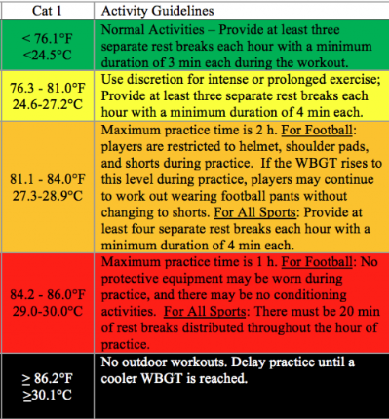
WBGT GUIDELINES
A WBGT device is a measurement tool that uses ambient temperature, relative humidity, wind, and solar radiation from the sun to get a measure that can be used to monitor environmental conditions during exercise. Establishing WBGT guidelines that dictate modifications in activity (work: rest ratios, hydration breaks, equipment worn, length of practice) at given WBGT temperatures play a huge factor in helping to prevent exertional heat stroke (EHS).
As environmental temperature and humidity increase, there is an increase in the heat stress that is placed on the exercising individual. Exercise in the heat causes athletes to rely on evaporation of sweat from the skin as the primary method of dissipating heat that is produced by the working muscles. As humidity increases, the ability to dissipate heat through evaporation is further hindered, thus causing the body to have an increased body temperature, which increases the risk of EHS.
As it was mentioned above, WBGT can be used to establish guidelines for activity modifications during physical activity in the heat.
School sanctioned athletics programs should use WBGT as a preventive measure against the heat. For example, the Georgia High School Athletics Association, amongst others, passed guidelines that mandate all state high schools measure WBGT and make necessary practice and game modifications depending on the WBGT reading. The guidelines are specific for the length of practice, number of breaks, and equipment that is allowed to be worn depending on WBGT temperature.
When establishing WBGT guidelines for physical activity, the guidelines must be region (geographic) specific. For example, an athlete playing football in Louisiana may be accustomed to warm environmental conditions, unlike a football player from Maine. A football player practicing in 90°F temperatures in Louisiana could be comfortable whereas a football player practicing in the same conditions in Maine could be experiencing the worst conditions they have felt all year, which would increase the risk of heat illness.

Reference: https://ksi.uconn.edu/prevention/wet-bulb-globe-temperature-monitoring/

Mental Health Emergency in Secondary School Athlete
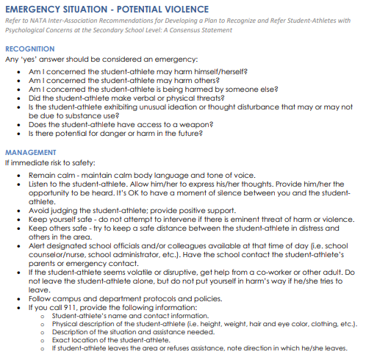

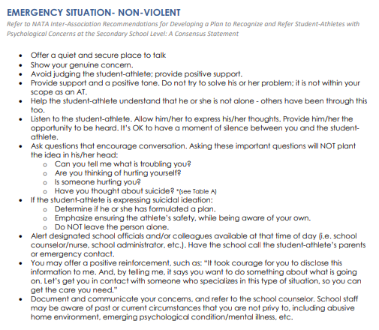
Emergency Contact Numbers:

School Counselor (A-L): Soteria Zouzas (603) 224-7413 ext. 283
School Counselor (M-Z): Shelby Loth (603) 224-7418 ext. 285
Principal: Andrea Elliot (603) 620-3549 (Cell)
Assistant Principal: Keith Bergeron (603) 224-7413 ext. 222
Athletic Director: Annie Mattarazzo (603) 491-6005 (Cell)
Child Welfare/Protective Services: (800) 894-5533
Crisis Hotline: 988

Lightning Safety Policies

A. All athletic staff and game personnel should monitor threatening weather. A chain of command should be established as to who makes the decision to suspend events. The emergency plan should include planned instructions for participants as well as spectators.

B. Be aware of potential thunderstorms that may form during scheduled athletic events or practices. Included here should include National Weather Service – issued (NWS) thunderstorm “watches” and “warnings” as well as signs of thunderstorms developing nearby. A “watch” means conditions are favorable for severe weather to develop in an area; a “warning” means that severe weather has been reported in an area and for everyone to take proper precautions.

C. Know where the closest “safe structure or location” is to the field or playing area and know how long it takes to get to that safe structure or location.
Safe structure or location is defined as:
➢ Any building normally occupied or frequently used by people, i.e., a building with plumbing and /or electrical wiring that acts to electrically ground the structure. A “dugout” is NOT a safe structure. Avoid using shower facilities for safe shelter and do not use the showers or plumbing facilities during a thunderstorm.
➢ In the absence of a sturdy, frequently inhabited building, any vehicle with a hard metal roof (not a convertible or golf cart) and rolled up windows can provide a measure of safety. A vehicle is certainly better than remaining outdoors. It is not the rubber tires that make a vehicle safe shelter, but the hard metal roof which dissipates the lightning strike around the vehicle. DO NOT TOUCH THE SIDES OF THE VEHICLE!

C. WHEN YOU FIRST HEAR THUNDER OR SEE LIGHTING, SUSPEND ACTIVITIES AND GO TO A SAFE SHELTER OR LOCATION. “IF YOU CAN SEE IT (LIGHTNING), FLEE IT (TAKE SHELTER).”
” IF YOU CAN HEAR IT (THUNDER) CLEAR IT (SUSPEND ACTIVITIES).”

WAIT UNTIL 30 MINUTES AFTER THE LAST OBSERVED LIGHTNING OR THUNDER BEFORE RESUMING ACTIVITIES.

Other Severe Weather and Natural Disasters

Tornado:
- When a warning is issued by sirens or other means, seek inside shelter. Consider the following:
  - Small interior rooms on the lowest floor and without windows,
  - Hallways on the lowest floor away from doors and windows, and
  - Rooms constructed with reinforced concrete, brick, or block with no windows.
- Stay away from outside walls and windows.
- Use arms to protect head and neck.
- Remain sheltered until the tornado threat is announced to be over.

Earthquake:
- Stay calm and await instructions from the Emergency Coordinator or the designated official.
- Keep away from overhead fixtures, windows, filing cabinets, and electrical power.
- Assist people with disabilities in finding a safe place.
- Evacuate as instructed by the Emergency Coordinator and/or the designated official.

Flood:
If indoors:
- Be ready to evacuate as directed by the Emergency Coordinator and/or the designated official.
- Follow the recommended primary or secondary evacuation routes.
If outdoors:
- Climb to high ground and stay there.
- Avoid walking or driving through flood water.
- If car stalls, abandon it immediately and climb to a higher ground.

Hurricane:
- The nature of a hurricane provides for more warning than other natural and weather disasters. A hurricane watch issued when a hurricane becomes a threat to a coastal area. A hurricane warning is issued when hurricane winds of 74 mph or higher, or a combination of dangerously high water and rough seas, are expected in the area within 24 hours.

Once a hurricane watch has been issued:
- Stay calm and await instructions from the Emergency Coordinator or the designated official.
- Moor any boats securely or move to a safe place if time allows.
- Continue to monitor local TV and radio stations for instructions.
- Move early out of low-lying areas or from the coast, at the request of officials.

- If you are on high ground, away from the coast and plan to stay, secure the building, moving all loose items indoors and boarding up windows and openings.
- Collect drinking water in appropriate containers.
- Once a hurricane warning has been issued:
- Be ready to evacuate as directed by the Emergency Coordinator and/or the designated official.
- Leave areas that might be affected by storm tide or stream flooding.
During a hurricane:
- Remain indoors and consider the following:
  - Small interior rooms on the lowest floor and without windows,
  - Hallways on the lowest floor away from doors and windows, and
  - Rooms constructed with reinforced concrete, brick, or block with no windows.

Blizzard:
If indoors:
- Stay calm and await instructions from the Emergency Coordinator or the designated official.
- Stay indoors!
- If there is no heat:
  - Close off unneeded rooms or areas.
  - Stuff towels or rags in cracks under doors.
  - Cover windows at night.
- Eat and drink. Food provides the body with energy and heat. Fluids prevent dehydration.
- Wear layers of loose-fitting, lightweight, warm clothing, if available.

If outdoors:
- Find a dry shelter. Cover all exposed parts of the body.
- If shelter is not available:
  - Prepare a lean-to, wind break, or snow cave for protection from the wind.
  - Build a fire for heat and to attract attention. Place rocks around the fire to absorb and reflect heat.
  - Do not eat snow. It will lower your body temperature. Melt it first.

If stranded in a car or truck:
- Stay in the vehicle!
- Run the motor about ten minutes each hour. Open the windows a little for fresh air to avoid carbon monoxide poisoning. Make sure the exhaust pipe is not blocked.
- Make yourself visible to rescuers.
  - Turn on the dome light at night when running the engine.
  - Tie a colored cloth to your antenna or door.
  - Raise the hood after the snow stops falling.
- Exercise to keep blood circulating and to keep warm.

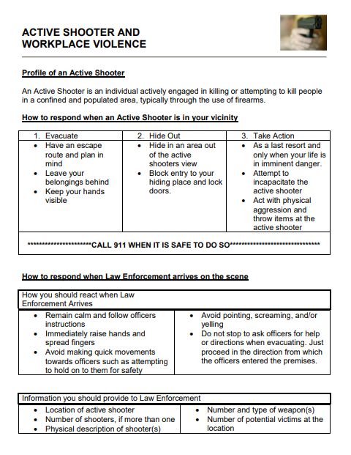

Approval and Verification Page:
This document has been read and revised by the Safe Sports Network athletic trainer, supervising physician and athletic administrator.
Supervising Physician: _____________________________________ Date: _____________________
Athletic Trainer: __________________________________________ Date: _____________________
Athletic Administrator: _____________________________________ Date: _____________________

Coach Acknowledgement of Review of EAP

I _____________________________________________________________ (print coach name/sport) have read and understand the Emergency Action Plan for Bishop Brady High School Athletics. I understand my roles and responsibility should an emergency occur in my presence. I have also rehearsed this Emergency Action Plan and understand my role in an emergency situation with an athletic trainer present and without. I have been given the opportunity to ask all questions and have received the proper answers to my questions.
I also understand that I must keep my CPR/AED and First Aid Certifications up to date and that it is my responsibility to ensure a lapse does not occur. I am also aware that I must be trained in concussion management, and it is my responsibility to ensure a lapse does not occur.

Coach Name (print)_________________________________________ Sport _________________________

Signature _________________________________________________ Date _________________________

